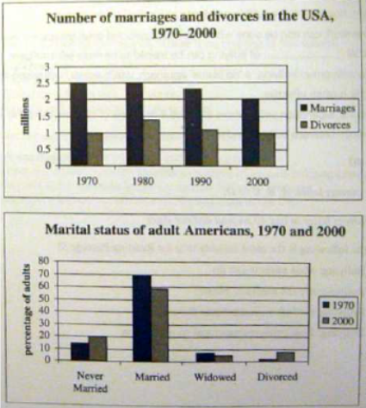

The first bar chart shows changes in the number of marriages and divorces in the USA, and the second chart shows figures for the marital status of American adults in 1970 and 2000.

It is clear that there was a fall in the number of marriages in the USA between 1970 and 2000. The majority of adult Americans were married in both year, but the proportion of single adults was higher in 2000.

In 1970, there were 2.5 million marriages in the USA and 1 million divorces. The marriage rate remained stable in 1980, but fell to 2 million by the year 2000. In contrast, the divorce rate peaked in 1980, at nearly 1.5 million divorces, before falling back to 1 million at the end of the period.

Around 70% of American adults were married in 1970, but this figure dropped to just under 60% by 2000. At the same time, the proportion of unmarried people and divorcees rose by about 10% in total. The proportion of widowed Americans was slightly lower in 2000.

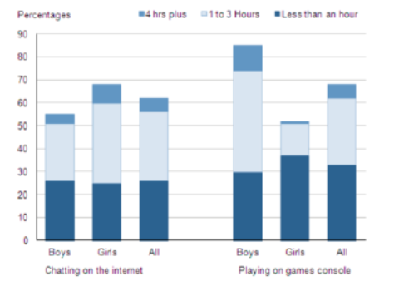

The bar chart compares the time spent by 10 to 15-year-olds in the UK on two activities, namely chatting online and playing computer games.

Overall, we can see that playing on games consoles is marginally more popular than chatting on the Internet. However, completely different trends can be seen if we look at the specific figures for boys and girls.

Boys aged between 10 to 15-year-olds clearly favor playing on games consoles over chatting online. According to the chart, while 85% of boys play computer games almost every day, only 55% chat online daily. Furthermore, the majority of boys play on their consoles for more than one hour each day, and 10% do this activity for four hours or more.

By contrast, girls prefer chatting online. Close to 70% of 10 to 15-year-old girls engage in online conversation each day, compared to about 50% of this cohort who play computer games. Of the girls who do play on consoles, most of them play for less than an hour, whereas most girls who chat online do so for more than one hour, and nearly 10% chat for four hours or more.

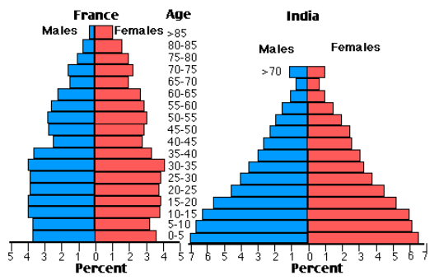

The two charts compare the populations of France and India in terms of age distribution by gender in the year 1984.

It is clear that the population of India was younger than that of France in 1984, with a noticeably larger proportion of people aged under 20. France, on the other hand, had a significantly larger percentage of elderly inhabitants.

In India, close to 14% of people were aged 5 or under, and each five-year age bracket above this contained an increasingly smaller proportion of the population. France’s population, by contrast, was more evenly distributed across the age ranges, with similar figures (around 7% to 8% of all people) for each five-year cohort between the ages of 0 and 40. Somewhere between 10% and 15% of all French people were aged 70 or older, but the equivalent figure for India was only 2%.

Looking more closely at gender, there was a noticeably higher proportion of French women than men in every cohort from age 50 upwards. For example, almost 3% of French 70- to 75-year-old were women, while just under 2% were men. No significant gender differences can be seen on the Indian population chart.